# WELCOME

Ms.

Julia

FEHLER

Flight Arrival Date: 17 Mar 2019 Flight Arrival Time: 07:10 Flight Number: TG475

Homestay Address: Elizabeth KARABELAS, 5 Easton Avenue, Sylvania, NSW, 2224

Mobile: 0431 152 159

If you arrive at the International Airport:

Once you come out of Customs, your driver will wait for you in front of ‘Optus Shop’

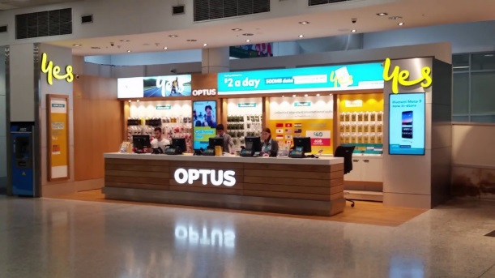

If you arrive at the Domestic Airport:

Please wait for your driver at the 'luggage area' as your driver will meet you there

In case of Emergency please contact:

Your Driver Coordinator (Lynton): (+61) 407 697 941

Global experience emergency number: (+61) 430 008 448

Email: [change@globalexperience.com.au](mailto:change@globalexperience.com.au)

PLEASE DO NOT LEAVE THE AIRPORT, WAIT FOR YOUR DRIVER